1. What exactly is []?

**Answer:**

[] is an empty list.

2. In a list of values stored in a variable called spam, how would you assign the value ‘hello’; as the third value? (Assume [2, 4, 6, 8, 10] are in spam.)

**Answer:**

Spam[2]=’hello’

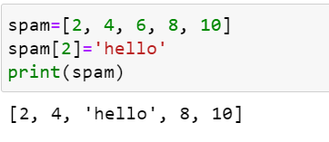

**Let’s pretend the spam includes the list [’a’,’b’,’c’,’d’] for the next three queries (3,4,5).**

3. What is the value of spam[int(int(‘3’* 2) / 11)]?

**Answer:**

Int(‘3’*2)=33

Int(33/11) = 3

Spam[3]=’d’

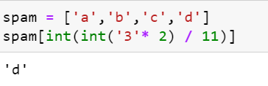

4. What is the value of spam[-1]?

**Answer:**

‘d’ (Negative index starts from end)

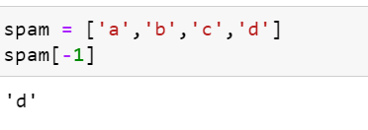

5. What is the value of spam[:2]?

**Answer:**

[‘a’, ’b’] (Includes index 0 and 1)

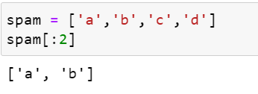

**Let’s pretend bacon has the list [3.14, ‘cat’, 11, ‘cat’, True] for the next three questions (6,7,8).**

6. What is the value of bacon.index(‘cat’)?

**Answer:**

1

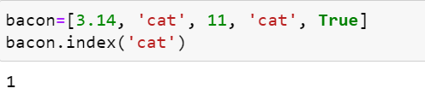

7. How does bacon.append(99) change the look of the list value in bacon?

**Answer:**

[3.14, ‘cat’, 11, ‘cat’, True, 99]

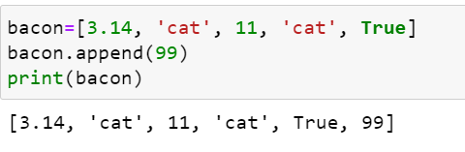

8. How does bacon.remove(‘cat’) change the look of the list in bacon?

**Answer:**

[3.14,11,’cat’,True]

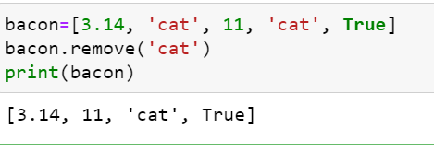

9. What are the list concatenation and list replication operators?

**Answer:**

+ is the list concatenation operator and * is the list replication operator.

10. What is difference between the list methods append() and insert()?

**Answer:**

append() will add the values only at the end of the list and insert() will add values anywhere in the list.

11. What are the two methods for removing items from a list?

**Answer:**

remove() and del keyword

12. Describe how list values and string values are identical.

**Answer:**

Both lists and strings are sequences. Both lists and strings can be passed to len() function, have indexes and slices, be used in for loops, be concatenated or replicated, and be used with the in and not in operators.

13. What’s the difference between tuples and lists?

**Answer:**

|  |  |
| --- | --- |
| **Lists** | **Tuples** |
| Lists are mutable | Tuples are immutable |
| Items are surrounded in [ ] parenthesis | Items are surrounded in ( ) parenthesis |
| It has more inbuilt methods | Less methods as compared to lists |
| e.g. list1=[‘Hi’,12,23.56,True] | e.g. (‘Hi’,12,23.56,True) |

14. How do you type a tuple value that only contains the integer 42?

**Answer:**

(42, ) (The trailing comma is compulsory)

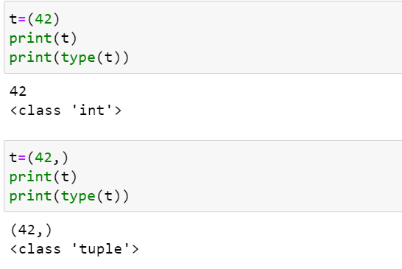

15. How do you get a list value’s tuple form? How do you get a tuple value’s list form?

**Answer:**

By using tuple() and list() functions respectively.

16. Variables that “contain” list values are not necessarily lists themselves. Instead, what do they contain?

**Answer:**

They contain references to the list values.

17. How do you distinguish between copy.copy() and copy.deepcopy()?

**Answer:**

|  |  |
| --- | --- |
| copy.copy() | copy.deepcopy() |
| This function will do a shallow copy. | This function will do a deep copy. |
| This will create a reference to original object. | It creates new object. |
| If you change copied object, it’ll also change the original object. | Changing new copied object doesn’t change the original object. |